**Power BI Assignment 2**

1. Explain the advantages of Natural Queries in PowerBi with an example?

* Natural queries in PBI is basically Power BI Q&A is free and available to all users to explore data and create visualizations
* Even before you start typing, Q&A displays a new screen with suggestions

to help you form your question

* As you type your question, PowerBi shows relevant and contextual suggestions

to help you quickly become productive with natural queries

* Q&A shows words with underlines to help you see which words the system recognized or didn't recognize. A solid blue underline indicates that the system successfully matched the word to a field or value in the data-model. If you enter a vague or ambiguous word, the field is underlined in orange dots. A red double-underline means Q&A didn't recognize the word at all
* Q&A helps to plot Line, Bar, Matrix, Table, Card, Area, Pie chart, Scatter/Bubble

Chart, Map

Below is example from Pizza Place Sales analysis :

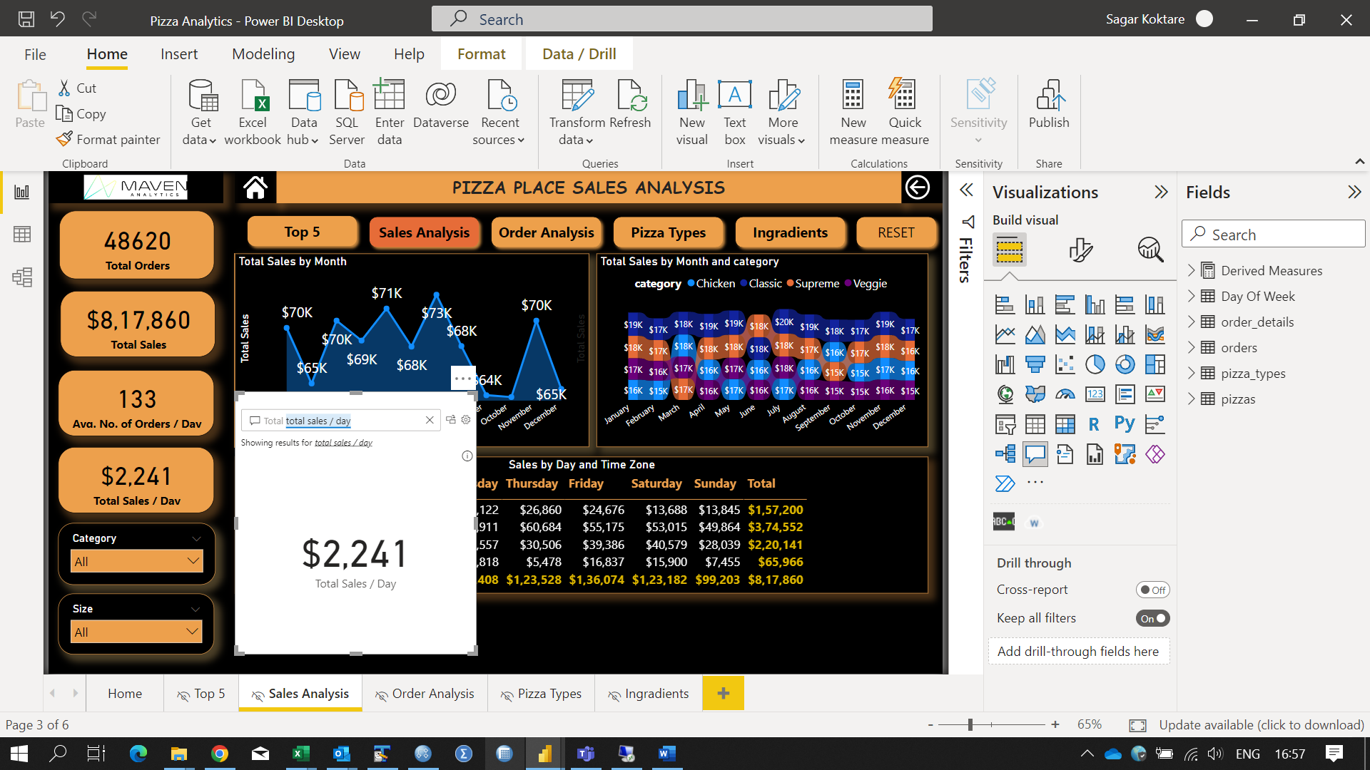 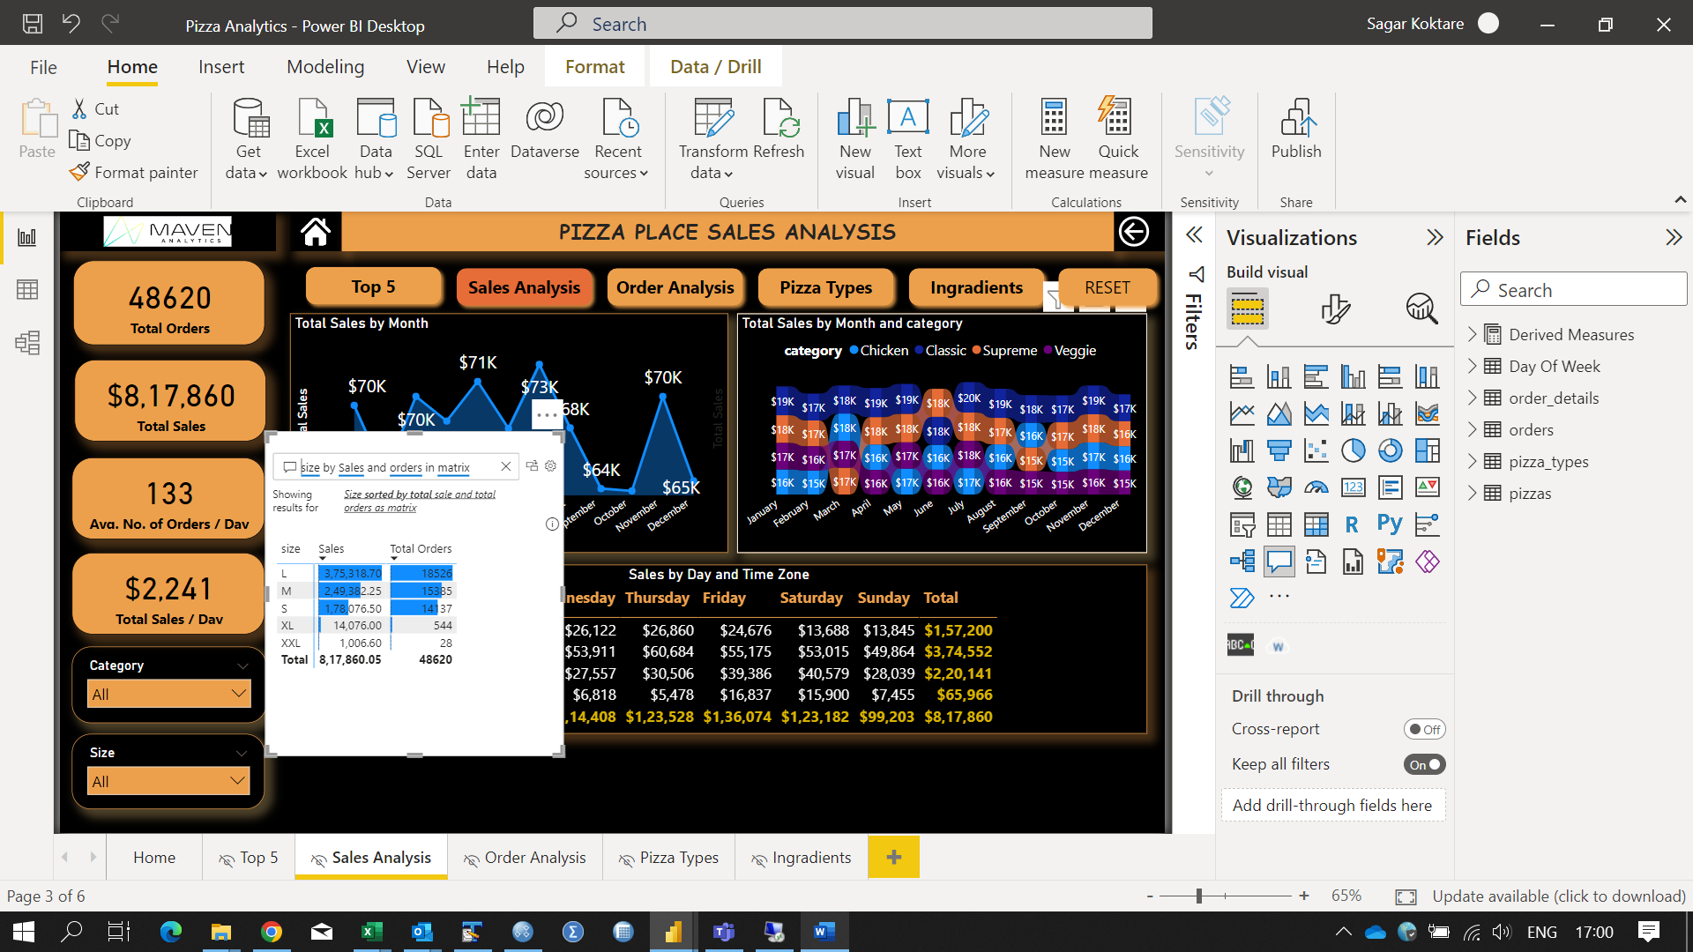

1. Explain Web Front End(WFE) cluster from Power BI Service Architecture?

* The **WFE** cluster uses Azure AD to authenticate clients, and provide tokens for subsequent client connections to the Power BI service. Power BI uses the **Azure Traffic Manager** (Traffic Manager) to direct user traffic to the nearest data center. Traffic Manager directs requests using the DNS record of the client attempting to connect, authenticate, and to download static content and files. Power BI uses the **Azure Content Delivery Network** (CDN) to efficiently distribute the necessary static content and files to users based on geographical locale

1. Explain Back End cluster from Power BI Service Architecture?

* The **Back-End** cluster determines how authenticated clients interact with the Power BI service. The **Back-End** cluster manages visualizations, user dashboards, datasets, reports, data storage, data connections, data refresh, and other aspects of interacting with the Power BI service. The **Gateway Role** acts as a gateway between user requests and the Power BI service. Users don't interact directly with any roles other than the **Gateway Role**. **Azure API Management** eventually handles the **Gateway Role**.

1. What ASP.NET component does in Power BI Service Architecture?

* A WFE cluster consists of an ASP.NET website running in the [Azure App Service Environment](https://learn.microsoft.com/en-us/azure/app-service/environment/intro). When users attempt to connect to the Power BI service, the client's DNS service may communicate with the Azure Traffic Manager to find the most appropriate (usually nearest) datacenter with a Power BI deployment.

1. Compare Microsoft Excel and PowerBi Desktop on the following features:

* Data import :
  + Excel : Have limited data imports options to connect with various data sources
  + PBI : Connects with 20+ data sources
* Data transformation :
* Excel : As compare to PowerBI, less functionalities to transform data into desired format
* PBI : Plenty of data transformations viz. row transformations, column transformations options are available
* Modeling :
* Excel : Ability to work with simple and structure data models
* PBI : Ideal for buidling complex data models easily
* Reporting :
* Excel : Simple and less attractive reports than those in Power BI
* PBI : More Beautiful, personalized, attractive and interactive visuals
* Server Deployment :
* Excel : Excel dashboards couldn't deploy on server and share with multiple people
* PBI : Using Power BI service, we could share reports to multiple users
* Convert Models :
* Excel : Excel need additional add-in to use PowerQuery functionality to create data model in excel
* Power BI : Using Power Query, we could connect with complex data models present on server or PowerBi directly detects relationships among table
* Cost :
* Excel : Power BI Desktop is free to download and use for personal use, but it takes  $10 per month per user to share reports with others
* PowerBi : Since we already have Excel, we need to spend additional money to procure this and build dashboards

1. List 20 data sources supported by Power Bi desktop

* Excel
* Text/CSV
* XML
* JSON
* Oracle Database
* IBM DB2 Database
* MySQL Database
* PostgreSQL Database
* Teradata Database
* SAP Business Warehouse server
* Amazon Redshift
* Google BigQuery (Beta)
* Azure SQL Database
* Salesforce Reports
* Google Analytics
* Facebook
* GitHub
* SQL Server database
* Azure Blob storage
* Snowflake
* Web
* Azure Databricks